NAME: Marian Datugan COURSE AND SECTION: BSIT 3B
Course: Web Systems Technology
Objective: Students will install, configure, and run Laravel or CodeIgniter on their local machine while demonstrating understanding of MVC structure, routing, and configuration files.
Rules:
1. Student must do it and be able to demonstrate how to setup the environment
2. Official documentation is allowed.
3. Each milestone must be signed off by the instructor.
4. Handwritten logs and reflections required.
5. Students must demonstrate working outputs live for verification.
CodeIgniter
Phase 1 – Environment Setup (Checkpoint 1)
Tasks |  | Progress Log | Comments/Feedback
Download CodeIgniter. |  | 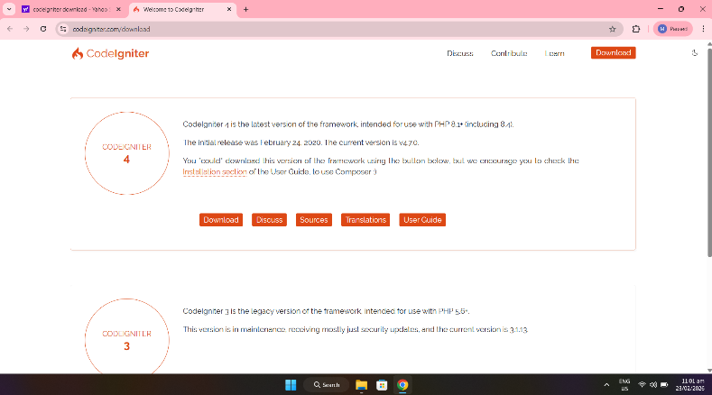 | In this step I’m on the official CodeIgniter download page. I downloaded the CodeIgniter version 4 in its website. Also I observed the clear separation between version 4 and version 3, also in other version.
Extract to htdocs (or local server folder). |  | 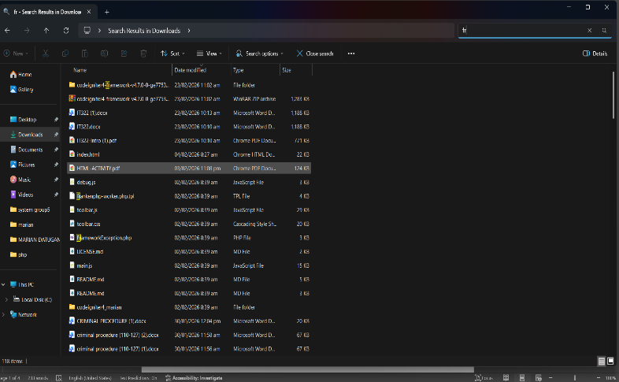 | When the downloading of CodeIgniter 4 has finish. I extract the CodeIgniter zip file from codeigniter4-framework then to place the files in htdocs folder.
Open project and display default page |  | 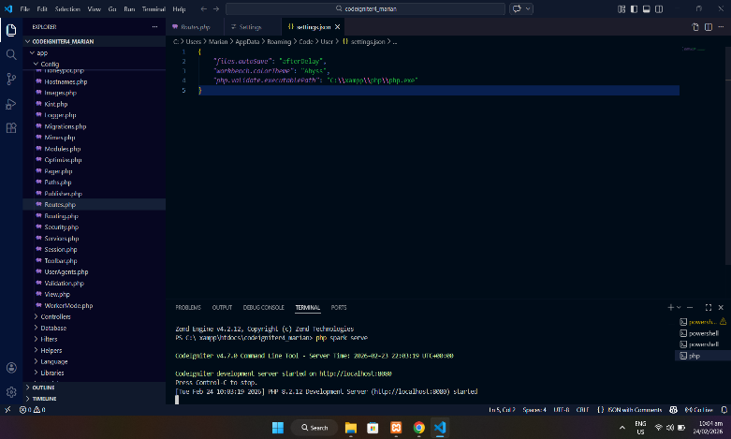 | Inside the project folder in Vs code terminal, I run the word php spark serve then successfully CodeIgniter development server started on http://localhost:8080. The default page display when we visit http://localhost:8080 and CodeIgniter automatically looks in app/Config/Routes.php.
Correct folder placement |  | 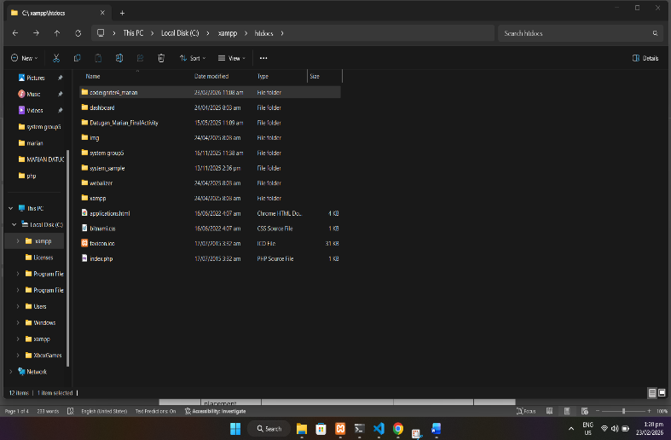 | I start the apache and mysql in Xampp Control Panel then I visit in xampp files to search for htdocs to paste my folder name codeigniter_marian to ensure that the placement is in the correct folder.
Working URL access. | 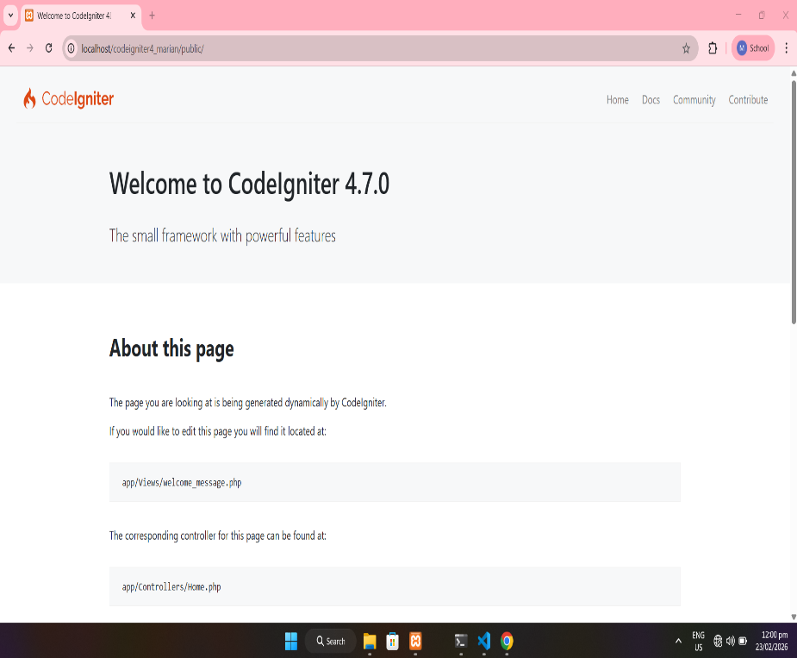 |  |  | After step by step process in downloading lastly we will check if the URL access is working. I check it in browser I typed my http://localhost/codeigniter4_marian/public.

Step-by-step installation summary:

Phase 2 – Environment Configuration (Checkpoint 2)
Tasks | Progress Log | Comments/Feedback
Configure baseURL.
Configure database connection.
Remove index.php from URL using .htaccess
- Explain baseURL.
_
- Explain public folder and writable folder.
_

Phase 3 – Structure Understanding (Checkpoint 3)
Identify and write:
1. Controllers folder
2. Views folder:
3. Models folder:
4. Routing configuration file
5. Purpose of writable folder: _____
Explain auto-routing vs defined routes.

Phase 4 – Mini Functional Output (Checkpoint 4)
Tasks | Progress Log | Comments/Feedback
Create a controller.
Create a view.
Define /profile route.
Pass dynamic data to view (full name, course/year, date).
Verify proper data passing and MVC connection.

- Draw the MVC diagram.
- 3 common errors and solutions.
- How to troubleshoot project load failures.

